**Master Functional Document**

|  |  |
| --- | --- |
| **Application** | NGERP - Centra |
| **Service Bundle** | Master Management |
| **Service Request** | Attribute Set Instance |

**Description:**

In Compiere (NGERP – Centra), the Attribute Set Instance is used to manage lot numbers and expiration dates for products. It helps track batches of items and ensures proper handling of products with a limited shelf life.

**Workflow Process:**

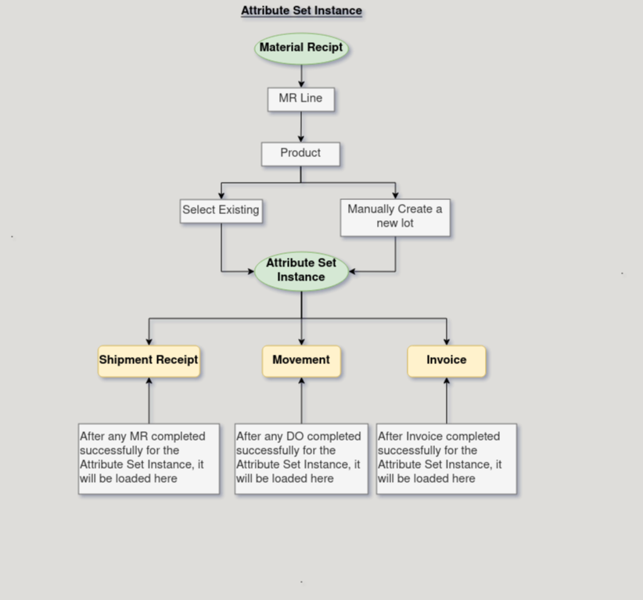

**Business Rules:**

* It is visible in both HQ and ROW.
* In HQ, all the records are shown.
* In ROW, only records for the particular region and HQ records are shown.
* Products with expiration dates must be tracked and monitored for timely use.
* Only products with valid lot numbers and expiration dates should be included in inventory.
* Expiring products should trigger alerts for inventory management or sales teams.